[Cloud Security Tutorial | Cloud Security Fundamentals | What is Cloud Security | Edureka](https://www.youtube.com/watch?v=0lw4KU5wHsk&t=687s&ab_channel=edureka%21)

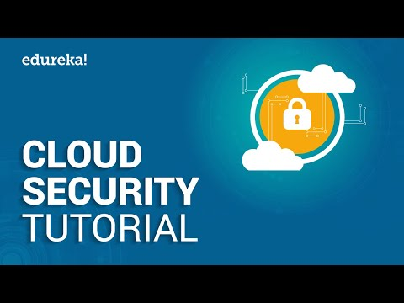

[AWS CLI Tutorial | Introduction To AWS Command Line Interface | AWS Training | Edureka](https://www.youtube.com/watch?v=sLtf7Sx8lsQ&ab_channel=edureka%21)

